**Docker Task -2**

**Task Description:**

Create a dockerfile, docker-compose file which when executed must display your basic details in the website.

**Techstacks needs to be used :**

* AWS EC2
* Docker

🡺Docker File created:

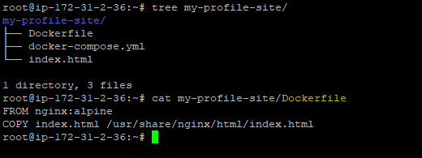  
  
🡺Docker compose File created:  
  
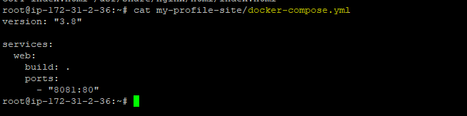  
  
**#docker-compose up --build -d**

